DGI Test Case Results

By: Michael Catanzaro
Date: 2012-02-11
Commit: 933b42a3f864dcb8fe738b78502286dffd2c116f

DGI #1: Zapdos
DGI #2: Raikou
DGI #3: Thundurus

Device Adapter: CRtdsAdapter

Test 1 PASS
Test 2 SKIPPED
Test 3-1 PASS
Test 3-2 PASS
Test 3-3 PASS
Test 4-1 PASS
Test 4-2 PASS
Test 4-3 PASS
Test 5-1 PASS
Test 5-2 PASS
Test 5-3 PASS

Test 1: Normal Operation of the DGI

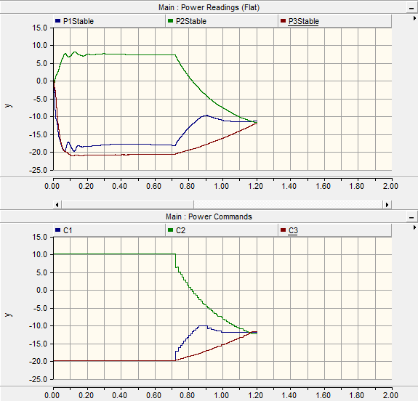
Test 3-1: DGI #1 killed and restarted

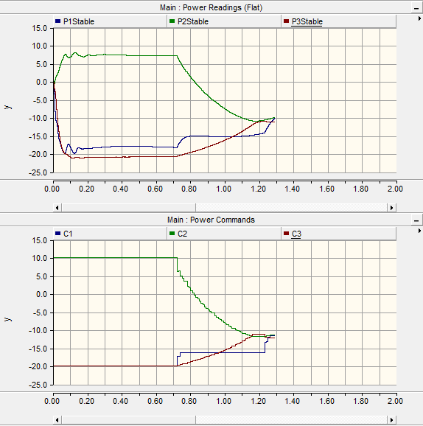
Test 3-2: DGI #2 killed and restarted

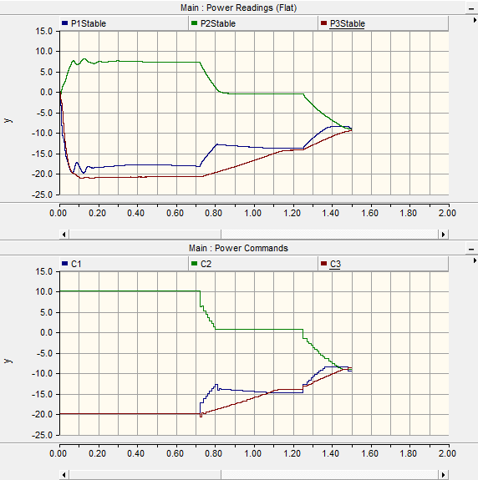
Case 3-3: DGI #3 killed and restarted
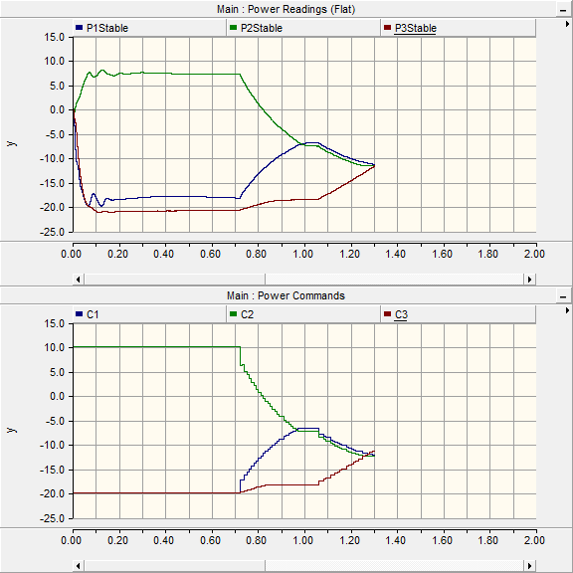
Test 4-1: DGI #1 isolated, then rejoins
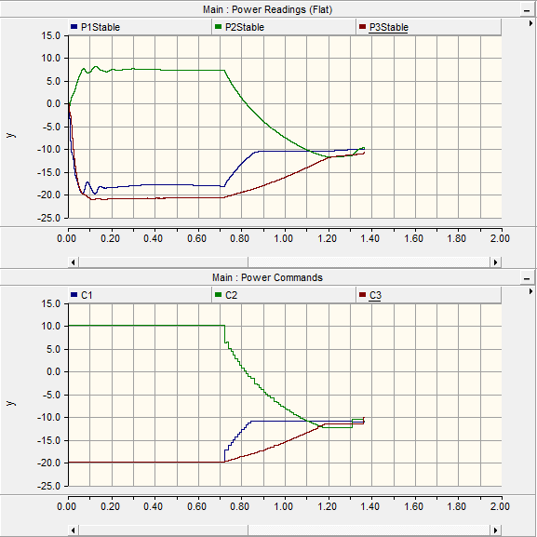
Case 4-2: DGI #2 isolated, then rejoins
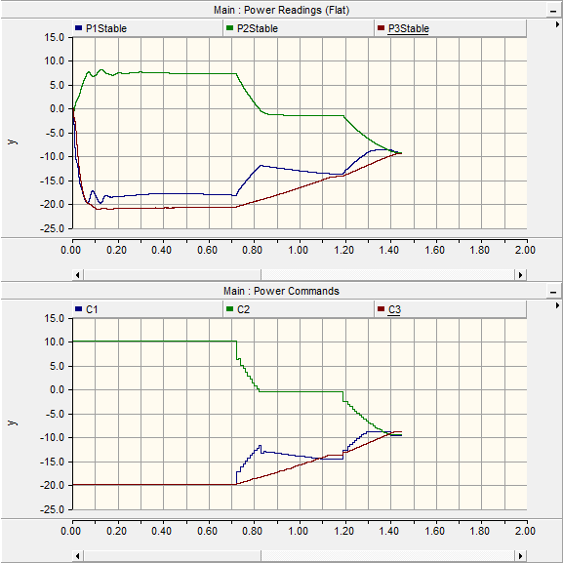
Test 4-3: DGI #3 isolated, then rejoins
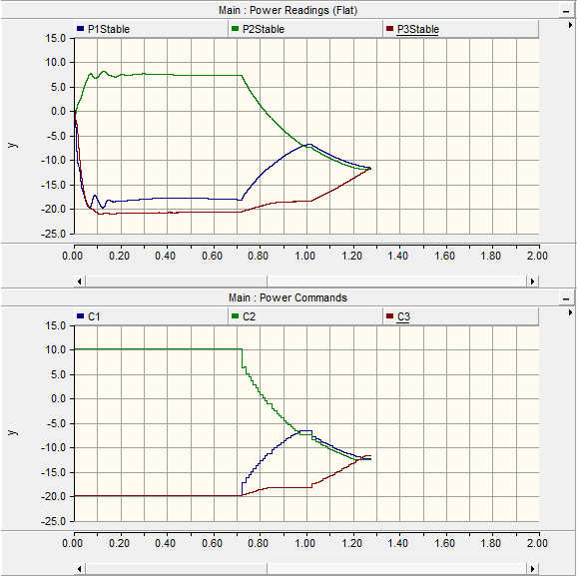
Test 5-1: DGI #1 joins a group in progress
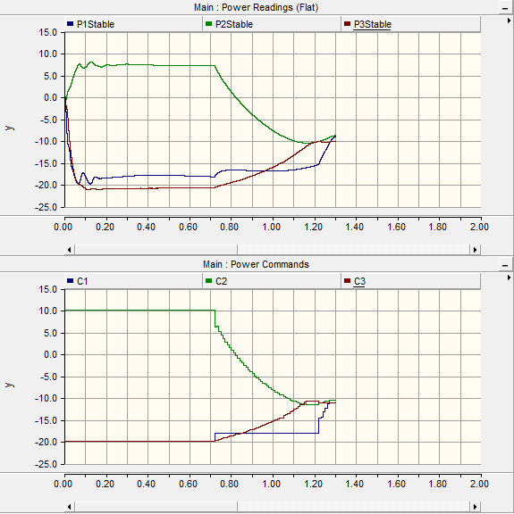
Test 5-2: DGI #2 joins a group in progress
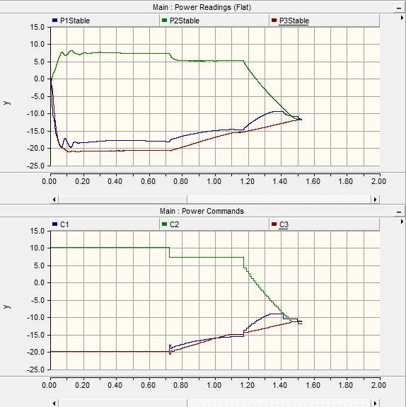
Although DGI #1's behavior here was unexpected, this is most likely a power simulation issue.
Test 5-3: DGI #3 joins a group in progress
